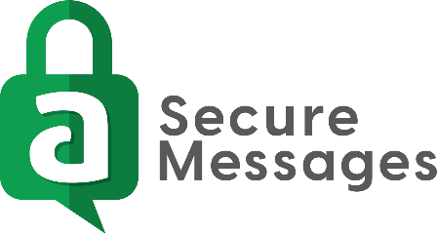

Set-Up Guide for Apple® Devices

Download the Amtelco Secure Messages App
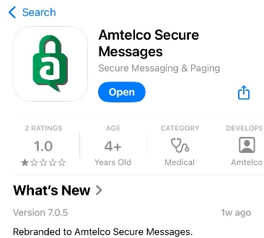
- Go to the Apple App Store app and search:
Amtelco

- Download/Install the Amtelco Secure Messages app; this is a free download.

Register the Amtelco Secure Messages App
- Open the Amtelco Secure Messages app.
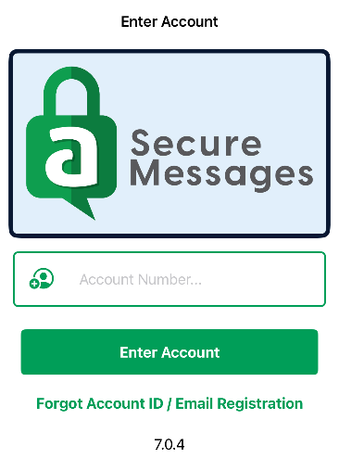
- If “Amtelco Secure Messages would like to send you notifications” is displayed, tap Allow.
- If “Amtelco Secure Messages would like to send you Critical Alerts” is displayed, tap Allow to enable high priority alerts to override the device Silent and Do Not Disturb modes.
- If “Storage Option” is displayed, tap Go to Settings to change the app’s maximum cache size.
- Enter Account: Enter your Account ID.
(This is given to you by your ASM service provider.)

Please enter this ID exactly as given. Tap Enter Account.

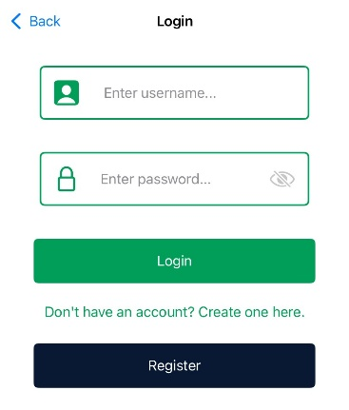
Your Account ID: ______________________________________

- Tap Create Account.
Note: Your credentials may be predetermined and given to you by your ASM service
provider. If this is the case, enter your credentials and choose Login.
- Create your credentials and additional settings for registration:
Display Name: Enter your name as you wish for it to appear to other app users
(e.g., Smith, John).
Username: Create a username. This is a unique identifier and will only be seen
by your ASM service provider.
Continued…

Password: Create a password. This is your Contact password. You will need this for any new device registration associated with your Contact account.
Note: The following items may be optional or required as determined by your ASM service provider.
Phone Number: Enter your 10-digit phone number without spaces or special characters (e.g., 6085551212).
Passcode: Create a passcode. The passcode is used on hand-held devices and will be required every time you open the ASM app. If your device is face/touch ID compatible, you can utilize that functionality by enabling it through your ASM app settings once a Passcode has been created.
Notification Interval: Select how often you would like to be notified for every new inbound MSM message. Notification behavior settings can also be found in your Device Settings; including but not limited to: sound, app icon indicator, device’s notification center.
Tap Next.

Your ASM Service Provider:

(Not AMTELCO)

For Help With ASM, Please Contact:

(Your ASM Administrative team)

